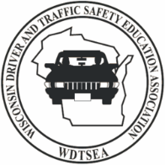 WDTSEA DISTINGUISHED SERVICES AWARD
NOMINATION FORM

WHO? The WDTSEA Distinguished Service Award is for an individual who has or is currently contributing to Driver Education or traffic safety in some capacity. This could be a retired teacher, DPI or DMV individual, or a former or current WDTSEA board member.

Does this person have to be retired? NO!

Date:

Name of Candidate:

Title or Position held at this time:

Number of years that nominee has been involved in Driver Education and/or traffic safety:

Why do you feel this individual is a candidate for WDTSEA “Distinguished Service Award”?

Explain some specific contributions this individual has had towards Driver Education and/or traffic safety.

*Person nominating this individual: _______________________________________________________
**Your phone#_____________________________ Your email - ________________________________

Please email your nomination form to Cathy Krull at ckrull@kimberly.k12.wi.us

